
TechInnovators
Nexus Inventory Tracking System
Dhruvi Maisuria – 4397146
University of the Western Cape

APEX Login Credentials
Workspace: DM20
Username: 4397146@myuwc.ac.za
Password: Dhruvi@apex20

Dhruvi Maisuria – 4397146
University of the Western Cape

APEX Login Credentials
Workspace: DM20
Username: 4397146@myuwc.ac.za
Password: Dhruvi@apex20

University of the Western Cape

APEX Login Credentials
Workspace: DM20
Username: 4397146@myuwc.ac.za
Password: Dhruvi@apex20

Dhruvi Maisuria – 4397146
University of the Western Cape

APEX Login Credentials
Workspace: DM20
Username: 4397146@myuwc.ac.za
Password: Dhruvi@apex20

Table of Contents
Introduction 2
System overview 3
System architecture & design 5
API documentation 6
Database design 11
Python libraries & dependencies 12
Setup & configuration 13
User manuals & guides 14
Monitoring & Reporting 18
Backup & Maintanence 19
Testing & Validation 25
Appendices 27

1. Introduction

1.1. Purpose of the Document
This document provides a comprehensive guide for the design, implementation, and use of Inventory Tracking System developed for TechInnovators Inc. It serves as a reference for administrators, employees, developers, and IT support staff, ensuring proper usage, efficient resource management, and smooth integration of the system into daily operations.

1.1.1. Scope
- Provides technical details about system architecture, database design, API endpoints, and Python integration.
- Includes setup and configuration instructions for the Oracle APEX application and Python-based employee interface.
- Contains user manuals for administrators and employees to guide equipment management tasks.
- Offers troubleshooting, maintenance, and support information to ensure system reliability.

1.1.2. Objectives
- Centralise Equipment Management: Maintain a single platform for all specialised equipment.
- Optimise Resource Allocation: Track usage patterns for efficient distribution.
- Prevent Loss and Misplacement: Monitor checkouts and returns to reduce financial loss.
- Enhance Operational Efficiency: Minimise delays caused by searching for equipment.
- Provide Reporting and Insights: Generate reports to support management decisions and resource planning.

1.1.3. Limitations
- Consumable supplies (e.g., small hardware components) are not tracked unless explicitly added.
- Maintenance scheduling and predictive servicing are not included.
- Python interface requires a QR code scanner; manual scanning is outside the system scope.
- The system is intended for internal use only and does not provide external access.

1.2. Audience
This documentation is intended for:
- System Administrators / Inventory Managers: Manage the Oracle APEX inventory application, add/update equipment, generate reports, and ensure data accuracy.
- Software Engineers / Developers: Maintain and enhance Python integration, understand APIs, and support debugging.
- Employees / End Users: Borrow, check out, and return equipment using the Python application, scan QR codes, and view usage history.
- IT Support Staff: Provide technical assistance, troubleshoot connectivity issues, and resolve integration errors.

1.3 Definitions, Acronyms, and Abbreviations
1.3.1. Definitions:
- Booking ID: Unique identifier for each equipment checkout transaction.
- QR Code: Two-dimensional barcode storing employee ID for check-in/check-out.
- Inventory: Complete list of all specialized equipment managed by the company.
- Check-in/Check-out: Process of returning or assigning equipment.
- Employee ID: Unique identification number for each employee.
- Administrator: Role responsible for managing inventory, assigning equipment, and generating reports.
- Python Application: Lightweight interface for employees to interact with Oracle APEX.
1.3.2. Acronyms:
- APEX: Oracle Application Express, a low-code development platform.
- IoT: Internet of Things.
- API: Application Programming Interface.
1.3.3. Abbreviations:
- SQL: Structured Query Language.
- GUI: Graphical User Interface.

2. System Overview

2.1. Architecture
The Equipment Inventory Tracking System uses a hybrid client-server architecture integrating Oracle APEX and a Python desktop application:
- Oracle APEX (Server-side):
  - Central inventory management for administrators.
  - Provides web interface to manage equipment, track usage, generate reports, and control allocations.
  - Exposes RESTful APIs for integration with external applications.
- Python Desktop Application (Client-side):
  - Employee interface connecting to Oracle APEX via secured APIs.
  - Allows employees to view equipment usage, check-in/return items using a Booking ID, and scan QR codes with a webcam.
- QR Code System:
  - Each employee has a unique QR code containing their Employee ID.
  - Validated during check-in/check-out using OpenCV (cv2).

2.2. Technologies Used
- Oracle APEX: Database-driven web platform.
- Oracle Database: Stores equipment, employee, and booking records.
- Python 3.x: Employee client and API integration.
- Tkinter: GUI framework for the desktop application.
- OpenCV (cv2): Captures and decodes QR codes.
- RESTful APIs: Custom-built endpoints for Python-APEX integration.

2.3. Dependencies
Software: Python 3.x, requests, tkinter, opencv-python, urllib3, Oracle APEX, ORDS.
Hardware: Employee laptops/workstations, webcams, secure Oracle servers.
Network: Reliable connectivity and proper firewall/access control for secure API communication.

3. System Architecture and Design
3.1. Architecture Diagram
- The below diagram displays a high-level architecture which includes Oracle APEX, Python integration and API communication.
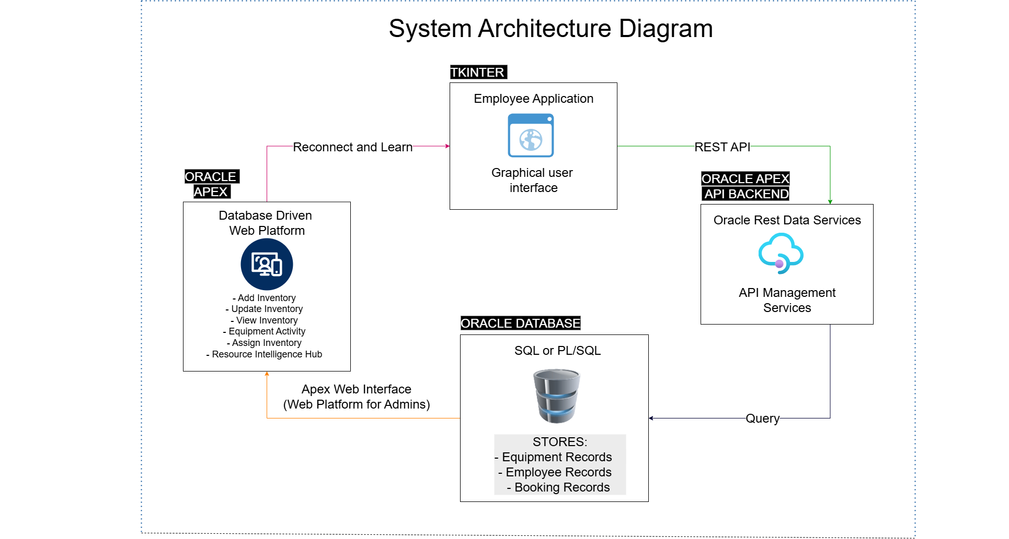

3.2. Component Description
1. Oracle APEX Inventory Management Application
- Central system for managing equipment records.
- Administrator functionalities: add/update equipment, assign items, generate reports.
- Interfaces with the Python client through custom REST APIs.
2. Python Employee Application
- Desktop application built with Python and Tkinter.
- Employee functionalities: view current/past equipment, return items via Booking ID, scan QR codes using OpenCV.
- Communicates securely with Oracle APEX via APIs.
3. Custom REST APIs (Oracle APEX ORDS)
- Enable integration between Oracle APEX and the Python application.
- Endpoints used:
  - GET: /getdata — fetch equipment usage.
  - POST: /postdata — checkout equipment.
  - PUT: /putdata — return/check-in equipment.
4. Oracle Database
- Stores equipment, employee, and booking data.
- Provides secure repository for reporting and auditing.
5. QR Code System
- Unique QR code for each employee containing their ID.
- Validated via the Python application during check-in/check-out.

4. API Documentation

Base URL - https://oracleapex.com/ords/dm20/myapi/

4.1. Overview
This API allows employees to book and return equipment. Inventory quantities are automatically updated. Intended for desktop apps, Python clients, and internal tools.

4.2. Authentication
- API requires a valid session or API key.
4.3. Endpoints
API endpoints developed specifically for this system include:
    - GET – https://oracleapex.com/ords/dm20/myapi/getdata
      - Retrieves employee equipment usage history and currently checked-out equipment.
    - POST – https://oracleapex.com/ords/dm20/myapi/postdata
      - Records new bookings or allocations when employees check out equipment.
    - PUT – https://oracleapex.com/ords/dm20/myapi/putdata
      - Updates records when employees return/check-in equipment.

1. GET /bookings
Description: Fetch all bookings, including item, employee, and booking details.
Request:
- Method: GET
- Headers: Accept: application/json
Response Example:
[
{
"booking_id": 101,
"item_id": 1,
"employee_id": 1234,
"date_booked": "2025-09-09T10:30:00",
"date_returned": null
}
]

2. POST /bookings
Description: Create a new booking. Automatically assigns the first available item and decreases inventory quantity.
Request:
- Method: POST
- Headers: Content-Type: application/json
- Body:
{
"employee_id": 1234
}
Success Response Example:
{
"status": "success",
"message": "Booking created successfully",
"booking_id": 101,
"item_id": 1
}

3. PUT /bookings
Description: Return equipment; updates booking and restores inventory quantity.
Request:
- Method: PUT
- Headers: Content-Type: application/json
- Body:
{
"booking_id": 101,
"employee_id": 1234
}
Success Response:
{
"status": "success",
"message": "Equipment returned successfully",
"booking_id": 101,
"item_id": 1
}
4.4. Error Responses
- 404 Not Found – Booking not found, already returned, or wrong employee.
- 500 Internal Server Error – Unexpected database error.

4.5. Parameters
Parameter | Type | Description
booking_id | Number | Unique booking identifier
item_id | Number | Assigned inventory item ID
employee_id | Number | Employee who made the booking
date_booked | Datetime | Booking start date/time
date_returned | Datetime | Booking end date/time, null if active

4.6. Data Validation & Business Rules
- Inventory quantity cannot go below 0.
- One active booking per item per employee.
- POST automatically selects the first available item.

Example Workflows
- Booking an Item
  - Employee scans QR or submits request → POST /bookings → Inventory quantity decreases → Booking record created.
- Returning an Item
  - Employee submits return → PUT /bookings → Inventory quantity increases → Booking date_returned updated.

4.7. Error Handling
- 404: Booking not found, already returned, or does not belong to employee.
- 400: Missing required parameters.
- 500: Unexpected database errors (SQL or system).

4.8. Pagination / Filtering (Optional)
- ?employee_id=1234 – filter by employee
- ?status=active – show only active bookings
- ?limit=50&offset=0 – pagination for large datasets

4.9. Versioning
- Current version: v1 (/v1/bookings)
- Changes tracked with a changelog.
5. Database Design
5.1. Database Schema
The database consists of the following key tables:
- Employees – Stores employee details, including personal information and department.
- Inventory – Maintains a list of all equipment, including available quantity.
- Bookings – Tracks which employee has booked which item, along with booking and return dates.
5.2. ERD DIAGRAM
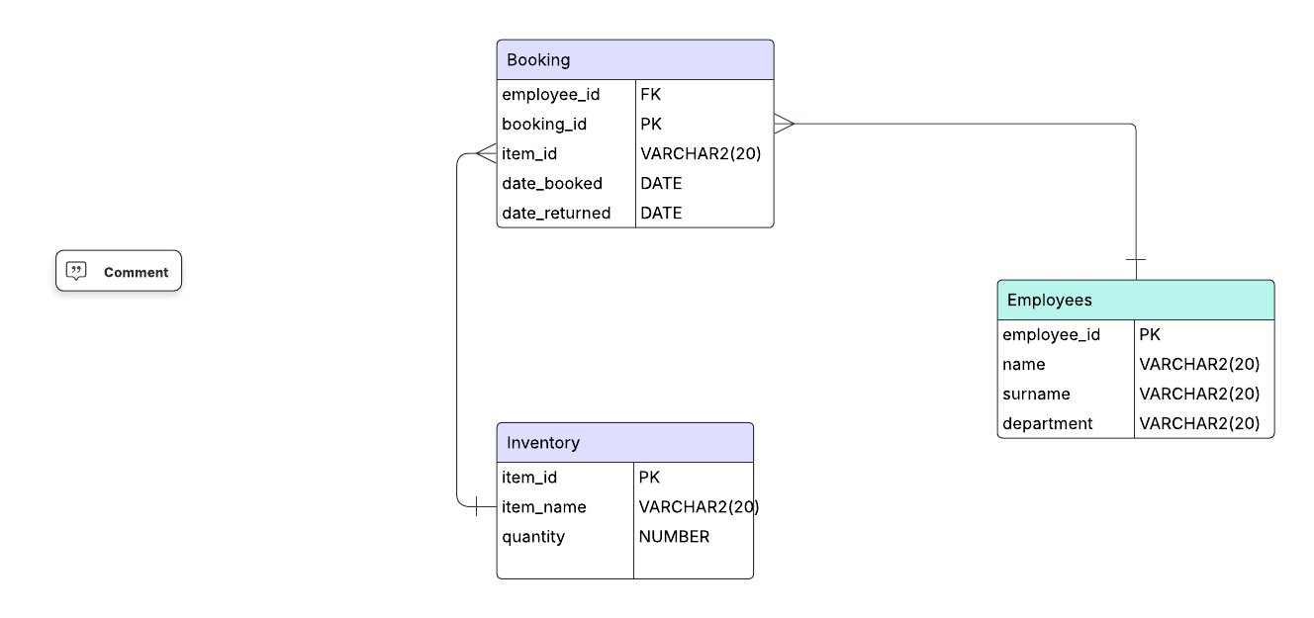

5.3. Data Dictionary
Table: Employees
Field Name | Data Type | Constraints | Description
employee_id | NUMBER | Primary Key | Unique identifier for each employee
name | VARCHAR2(100) | NOT NULL | Employee’s first name
surname | VARCHAR2(100) | NOT NULL | Employee’s surname
department | VARCHAR2(100) | NULL allowed | Department the employee belongs to

Field Name | Data Type | Constraints | Description
item_id | VARCHAR2(20) | Primary Key | Unique code for each equipment item
item_name | VARCHAR2(100) | NOT NULL | Descriptive name of the equipment
quantity | NUMBER | NOT NULL, ≥ 0 | Number of available units in stock

Field Name | Data Type | Constraints | Description
booking_id | NUMBER | Primary Key | Unique identifier for each booking transaction
item_id | VARCHAR2(50) | Foreign Key → inventory(item_id) | Equipment item being booked
employee_id | NUMBER | Foreign Key → employees(employee_id) | Employee who booked the item
date_booked | DATE | NOT NULL | Date the equipment was checked out
date_returned | DATE | NULL allowed | Date the equipment was returned
5.3. Authentication and Security
- API access requires employee verification via QR code and Booking ID.
- Requests are transmitted over HTTPS to ensure data confidentiality.
5.4. Error Codes and Handling
HTTP Code | Description | Example Message
400 | Bad Request | "Missing required field: employee_id"
401 | Unauthorised | "Invalid QR code or token"
404 | Not Found | "Booking ID not found"
409 | Conflict | "Equipment already checked out"
500 | Internal Server Error | "Unable to process request"
- All error responses are returned in JSON format:
{
"status": "error",
"message": "Booking ID not found",
"code": 404
}

6. Python Libraries and Dependencies

6.1. Tkinter
- Provides the Graphical User Interface (GUI) for the employee-facing application.
- Enables windows, buttons, labels, and input fields for employee interactions.
- Included with Python, no separate installation required.

6.2. Requests
- Handles HTTP communication between the Python client and Oracle APEX APIs.
- Used for sending GET, POST, and PUT requests to custom-built REST endpoints.
- Installation:

6.3. OpenCV (cv2)
- Facilitates webcam access for capturing QR codes.
- Provides image processing capabilities to improve QR code recognition.
- Installation:

6.4. Urllib3
- Supports secure HTTP connections.
- Manages SSL warnings and connectivity handling for API requests.
- Installation (if not bundled with Python):

6.5. Additional Dependencies
- json / apex_json (via ORDS API) – for encoding and decoding JSON data in API requests/responses.
- datetime – for handling dates and timestamps in bookings and returns.
- threading – for running tasks like webcam scanning concurrently without freezing the GUI.

7. Setup and Configuration

7.1. Hardware Requirements

7.1.1. Server Requirements (Oracle APEX & Database)
Component | Minimum | Recommended
Processor | Quad-Core 2.5 GHz | 8-Core 3.0 GHz
RAM | 16 GB | 32 GB
Storage | 500 GB SSD | 1 TB SSD
Network | Stable wired/wireless | High-bandwidth connection

7.1.2. Client Machine Requirements (Python Application)
Component | Minimum | Recommended
Processor | Dual-Core 2.0 GHz | Quad-Core 2.5 GHz
RAM | 8 GB | 16 GB
Storage | 100 GB HDD/SSD | 250 GB SSD
Webcam | Required for QR code scanning | High-resolution webcam
Operating System | Windows 10/11 | Windows 11/macOS/Linux

7.2. Software Requirements

7.2.1. Backend
- Oracle Database – Version 19c or higher
- Oracle APEX – Version 22.x or higher
- Oracle REST Data Services (ORDS) – Configured for API endpoints

7.2.2. Client Application (Python)
- Python – Version 3.9+
- Python Libraries: requests, opencv-python, tkinter, urllib3
- IDE (optional for development): Visual Studio Code
- QR Code Scanner – Webcam configured with OpenCV

7.3. Setup Instructions

7.3.1. Oracle APEX Application Installation
- Log into the Oracle APEX workspace.
- Create a new application or import the pre-built APEX application file.
- Configure the database schema with the following tables:
  - Employees
  - Inventory
  - Bookings
- Set up RESTful services via ORDS for API endpoints:
  - GET /myapi/getdata to Retrieve data
  - POST /myapi/checkout to Checkout equipment
  - PUT /myapi/putdata to Return/check-in equipment
- Assign administrator users and define access privileges.
- Test the application by adding sample equipment and creating bookings.

7.3.2. Python Desktop Application Installation
- Install Python 3.9+ on client machines.
- Install required libraries:
- pip install requests opencv-python tkinter urllib3
- Download or clone the application source code: git clone https://github.com/techinnovators/equipment-tracker.git
- cd equipment-tracker
- Ensure webcam or QR code scanner drivers are installed.
- Run the Python application to verify connectivity with Oracle APEX APIs:
- python main.py

7.3.3. QR Code Scanning Setup
- Ensure the webcam is functional and accessible to the Python application.
- Attach employee ID QR codes to staff badges.
- The Python client will:
a) Capture the QR code via OpenCV
b) Decode the employee ID
c) Verify it against the API endpoints

7.4. Configuration Settings and Options

7.4.1. Database Connection
- Configure the Oracle APEX application to connect to the Oracle Database schema containing employees, inventory and bookings.

7.4.2. API Endpoint Configuration
- In the Python application, update API URLs:
API_URL_GET = "https://oracleapex.com/ords/dm20/myapi/getdata"
API_URL_POST = "https://oracleapex.com/ords/dm20/myapi/checkout"
API_URL_PUT = “https://oracleapex.com/ords/dm20/myapi/putdata”

7.4.3. User Roles and Permissions
- Administrators: Full access to Oracle APEX for managing equipment, bookings, and reports.
- Employees: Limited access to Python application for viewing, checking out, and returning equipment only.
- Configure role-based access control (ACLs) in Oracle APEX accordingly.

7.4.4. QR Code Scanner Settings (Python App)
Setting | Description
CAMERA_INDEX | Default webcam (0)
SCAN_TIMEOUT | Maximum scan duration in seconds (e.g., 30)

7.4.5. Admin Options (Oracle APEX)
- Add/Edit Equipment
- Generate Usage Reports
- Manage Bookings & Allocations

7.4.6. Employee Options (Python App)
- View Active Checkouts
- View Usage History
- Return Equipment via Booking ID + QR Scan

8. User Manuals and Guides

8.1. End-User Documentation (Employee/User Manual)

8.1.1. Purpose of the Application
The Equipment Inventory Tracking Application is designed to streamline the management of company resources and ensure efficient utilization of equipment. This application allows employees to borrow and return equipment using QR codes, providing a fast and secure method of tracking inventory.
The system integrates a Python-based client application with the company's Oracle APEX backend through custom-built APIs. This integration ensures that all transactions are updated in real-time and that equipment usage data is consistently recorded.

Key Features for Employees
- View Equipment Usage: Employees can generate a report showing the equipment they have used in the past as well as equipment currently assigned to them.
- Return/Check-In Equipment: Employees can return equipment by entering the Booking ID associated with the specific item and scanning a physical QR code embedded with their employee ID. This process automatically records the return in the system and updates the inventory status.
Features Overview:
- Check out equipment
- Return equipment via QR scan
- View active checkouts
- View usage history
8.1.2. Step-by-Step Usage Scenarios
- Checking out equipment:
  - Open Python application
  - Enter Employee ID or scan QR code
  - Select equipment from the list
  - Confirm checkout
- Returning equipment:
  - Scan QR code from badge
  - Enter Booking ID
  - Confirm return

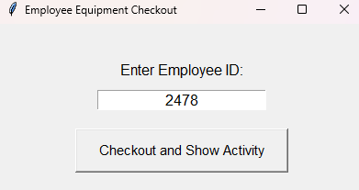

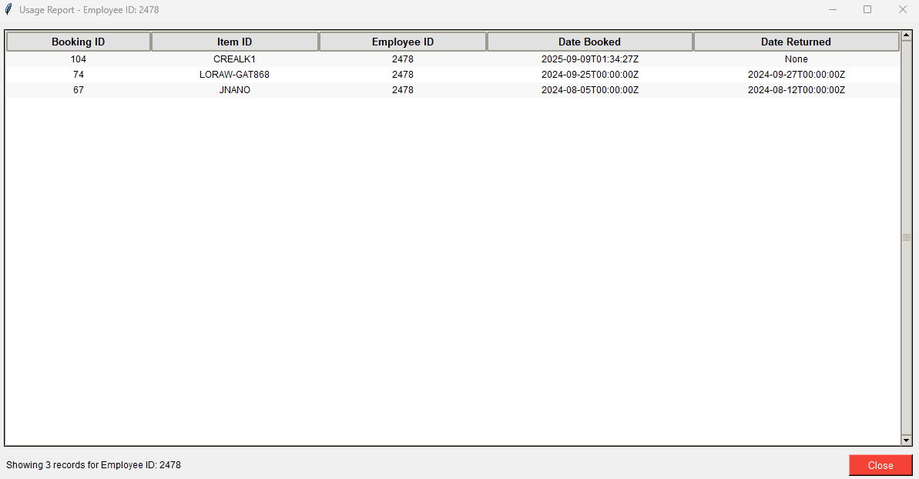

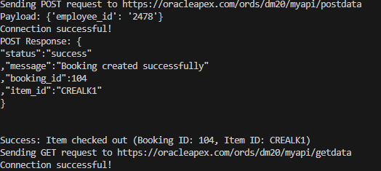

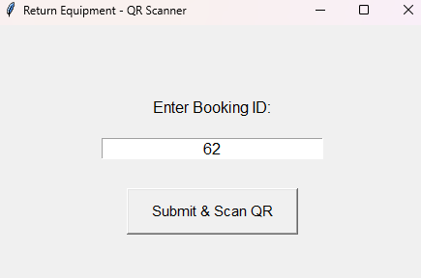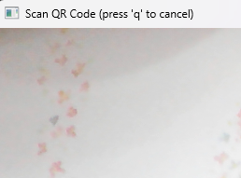

8.2. Administrator Guide (Admin Manual)

8.2.1. Purpose
The Administrator Guide provides detailed instructions for managing and maintaining the Equipment Inventory Tracking System. It is intended to ensure the system operates smoothly, data integrity is maintained, and users can efficiently access the application.
Admin tasks include:
- Managing the Oracle APEX system: Creating workspaces, configuring user roles, and maintaining security settings.
- Database management: Monitoring and maintaining the Oracle Database, including tables for employees, equipment, bookings, and transactions.
- Application configuration: Updating system settings, managing APIs, and ensuring integrations between the Python client and APEX backend function correctly.
- Monitoring and reporting: Generating reports on equipment usage, overdue returns, and inventory status to support resource planning.

8.2.2. System Management Tasks

a. Add Inventory
- Navigate to the Inventory Management page in Oracle APEX.
- Use the “Add New Item” form to enter details such as:
  - Item ID, Item Name and Quantity.
- Click Add Item to store the new entry in the database and the changes will be reflected in the View Inventory Interactive grid report.

b. Update Inventory
- Use the legacy page to select item name and add quantity.
- Save changes to update records instantly in the View Inventory report.

c. View Inventory
- Access the Interactive Grid to:
  - Edit, save, delete, add, or duplicate rows.
  - Apply filters and sorting for better visualisation.
- Review graphical visualisations showing:
  - Top 5 most available items by percentage of total stock
  - Top 5 lowest stock items
  - Fastest Moving Items (Top 5 Most Booked)

d. Equipment Activity
- Access the Equipment Activity Grid to view logs of checkouts and returns.
- Supports editing and data export.
- Includes 4 visualisations, such as:
  - Employee Usage Leaderboard
  - Equipment Turnaround Time
  - Active vs Returned Inventory
  - Employee Equipment Activity

e. Assign Inventory
- Select item id, employee id and book a date from a calendar.
- Create a booking record with a Booking ID.
- Confirm and assign equipment — record is automatically updated in the database and changes are reflected in the equipment activity table.

f. Resource Intelligence Hub
- Dashboard with 3 visualisations, such as:
  - Equipment Return Trend
  - Inventory Turnover
  - Employee Equipment Usage Over Time

9. Monitoring and Reporting

9.1. Generate Usage Reports
- Navigate to the Reports Dashboard in Oracle APEX.
- Available reports include:
  - Active Checkouts → Lists all currently borrowed equipment with Booking ID, Employee ID, and due date.
  - Inventory Levels → Displays total stock, available units, and reserved items for each category.
  - Overdue Items → Highlights bookings that have not been returned by the due date.
- Reports can be:
  - Exported to Excel, PDF, or CSV.
  - Filtered by date range, employee, or equipment type.

9.2. Track Employee Performance & Equipment Usage
- Use the Equipment Activity Grid and Resource Intelligence Hub for employee-focused reporting.
- Monitor:
  - Top Employees by Usage → Employees with the most checkouts.
  - Return Patterns → Identify employees with repeated overdue returns.
  - Turnaround Time → Average time equipment remains checked out.
- These metrics help management enforce accountability and optimize equipment allocation.

9.3. Real-Time Dashboards
- Visual dashboards in APEX provide at-a-glance insights into:
- Current stock levels.
- Most frequently booked equipment.
- Historical usage trends.
- Data is updated dynamically from the Oracle Database to ensure accuracy.

10. Backup & Maintenance

10.1. Database Backup
- Daily Backups: Schedule automated backups of the Oracle Database (full export of schemas including employees, equipment, and bookings).
- Manual Backup (if needed):
  - Use Oracle Data Pump (expdp) to export database schema.
  - Store backups on a secure external storage or cloud drive.
  - Maintain at least 7 days of backup history for rollback purposes.

10.2. Database Restore
- In case of system failure or data corruption:
  - Use Oracle Data Pump (impdp) to import the latest backup.
  - Verify schema integrity (employees, equipment, bookings).
  - Test the APEX application after restore to confirm proper functionality.

10.3. System Maintenance
- Regular Maintenance Tasks:
  - Monitor database size and performance using Oracle SQL Developer.
  - Archive old booking records (e.g., older than 2 years) to optimize query performance.
  - Apply Oracle Database and APEX security patches regularly.
- User Account Management:
  - Add, update, or disable employee accounts in APEX.
  - Assign appropriate roles (Admin, Employee, Manager) via the APEX Security Console.
  - Review user logs for unauthorized access attempts.

10.4. Approve or Manage Bookings
- Admins can approve pending booking requests.
- Cancel or modify bookings if equipment is unavailable.
- Ensure proper record updates are reflected in both the equipment activity log and employee usage reports.

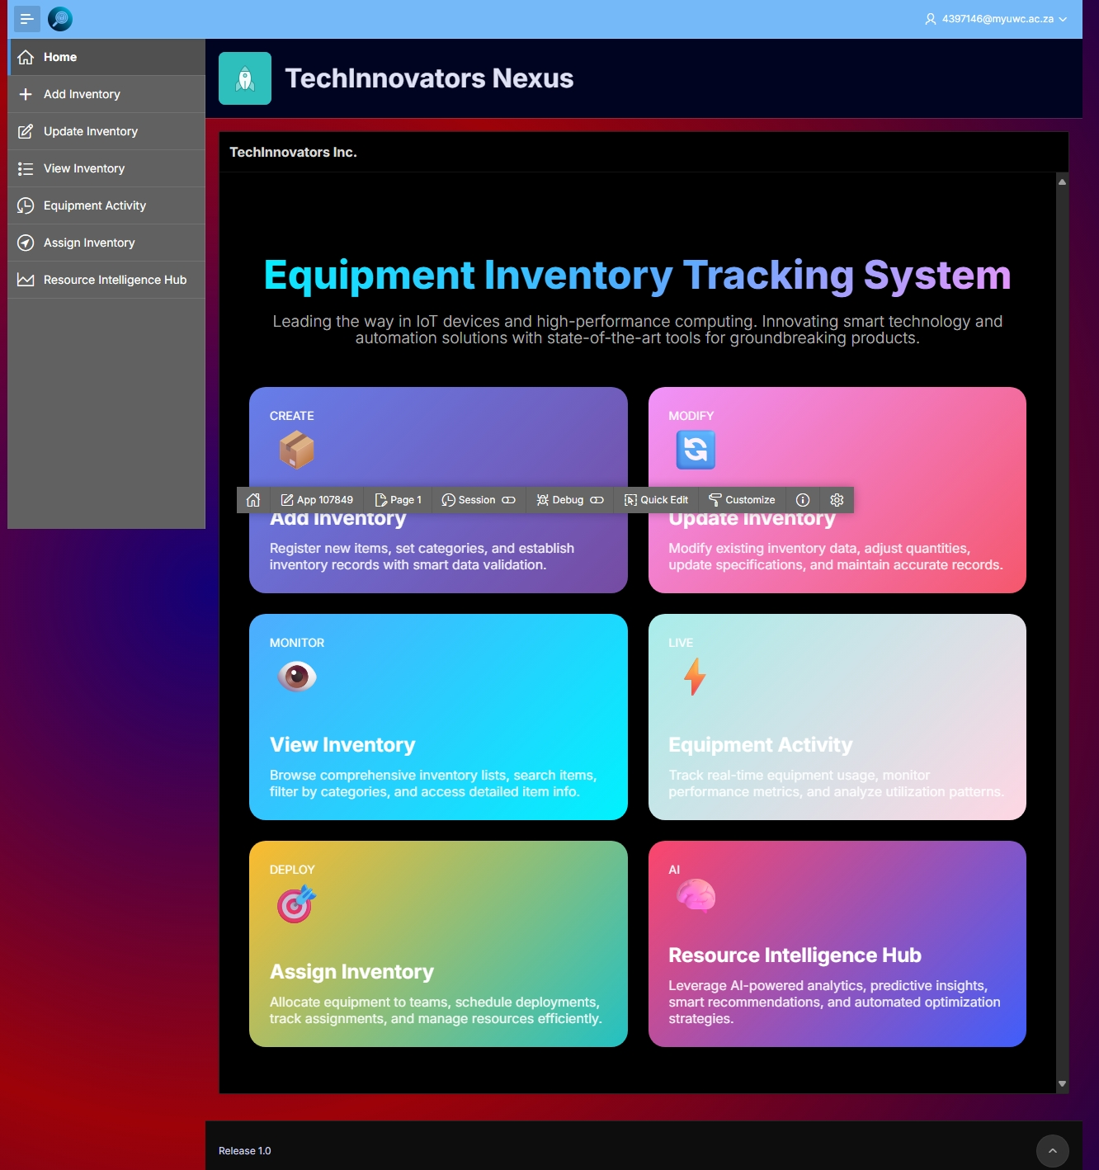

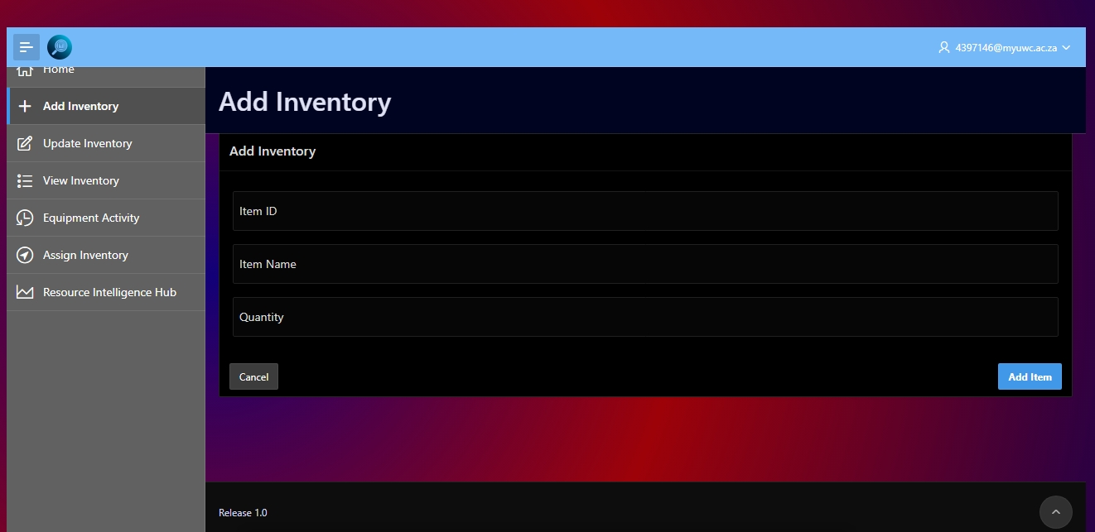

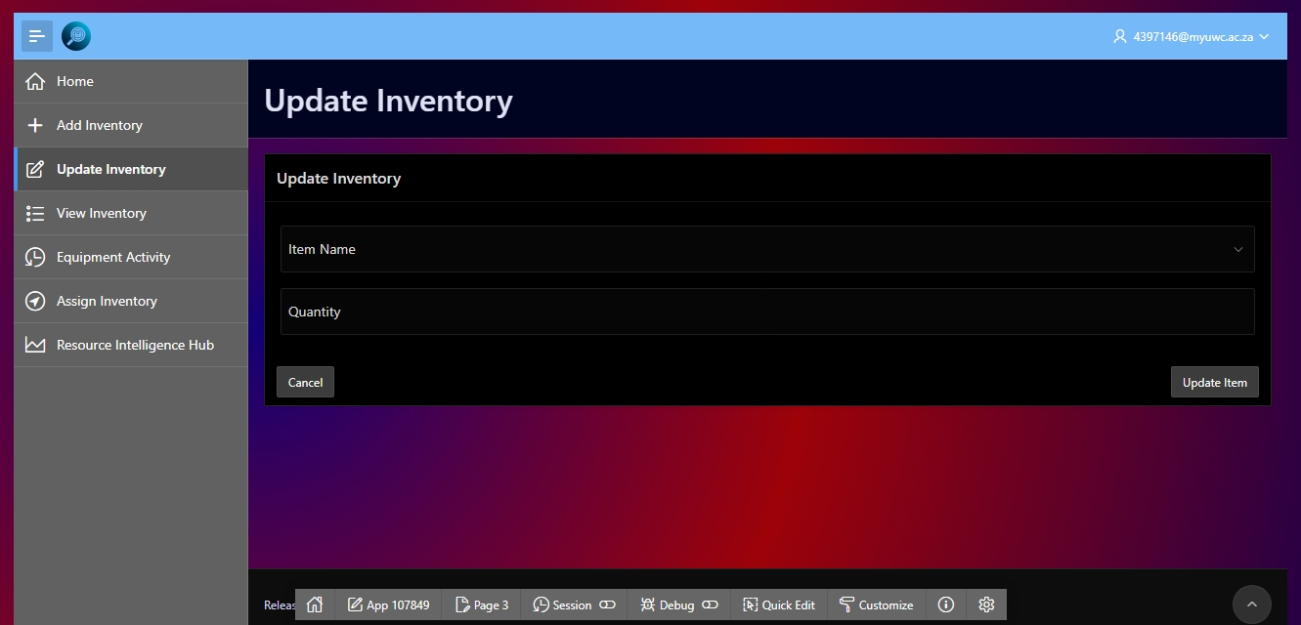

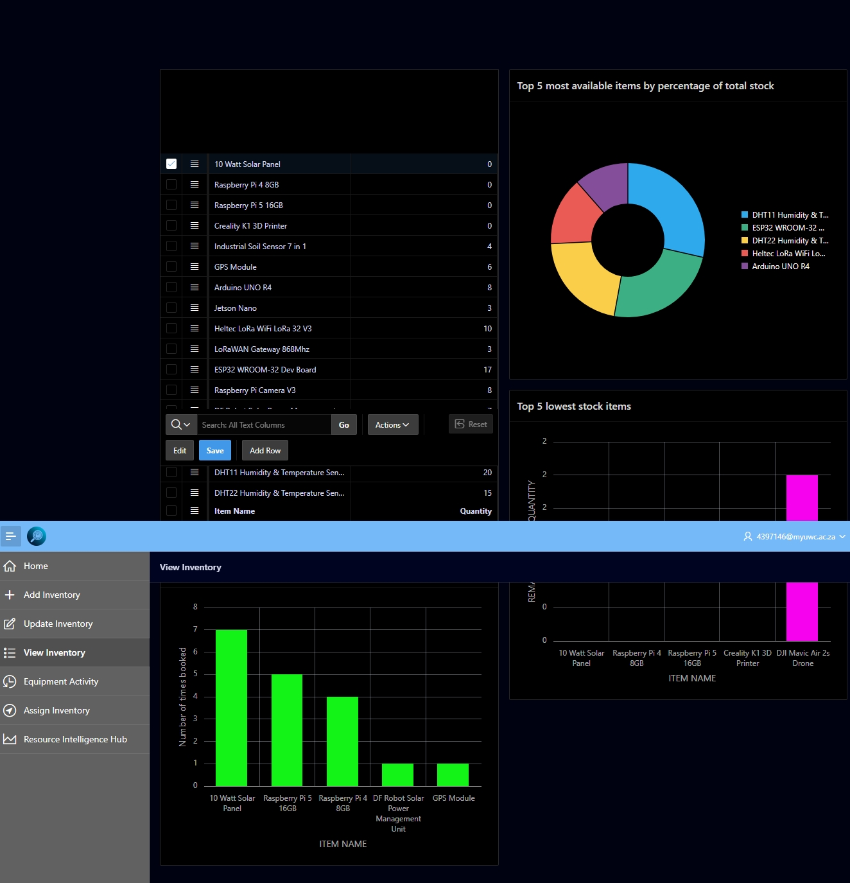

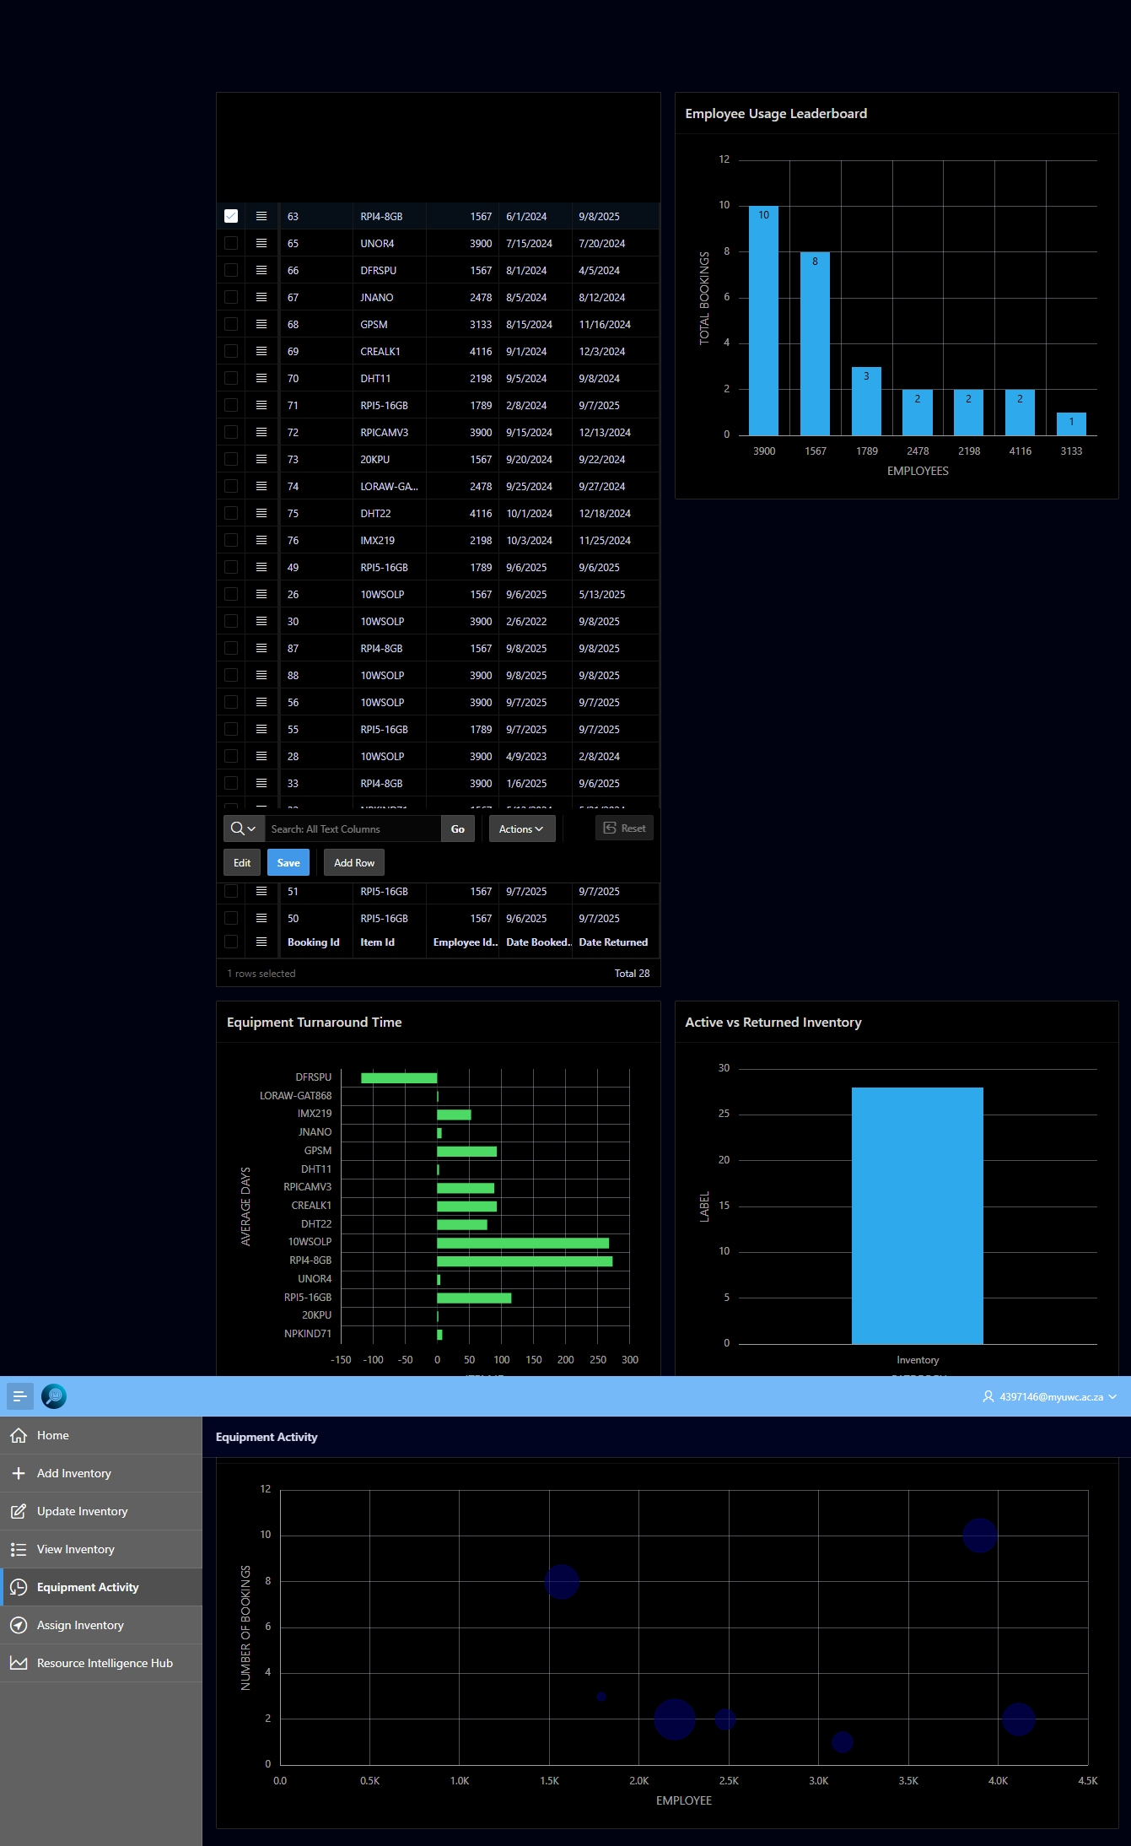

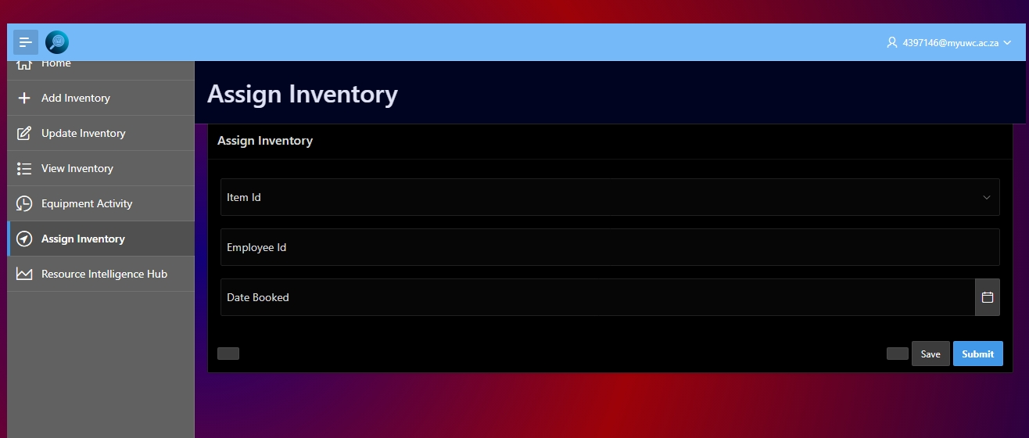

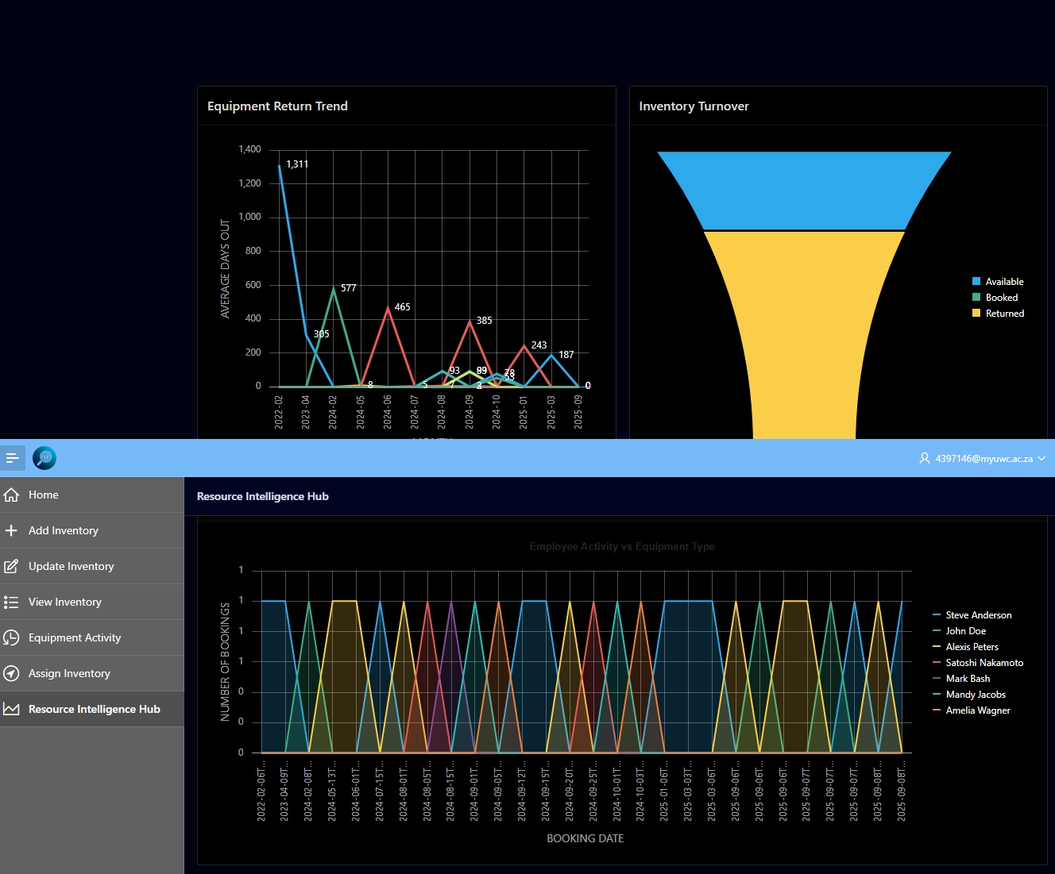

11. Testing and Validation
11.1. Test Plan
The system underwent the following types of testing:
    - Unit Testing
  - Each module or function was tested individually.
  - Examples: Python functions for API requests, QR code scanning, database insert/update functions.
    - Integration Testing
  - Verified that the Python application communicates correctly with Oracle APEX APIs.
  - Tested complete workflows: check-out, return, and viewing equipment usage.
    - User Acceptance Testing (UAT)
  - Conducted with sample admin and employee users.
  - Ensured that the system meets functional requirements and is user-friendly.
  - Collected feedback to improve usability and workflows.
11.2. Test Cases
Administrator Workflow Test Cases
Test Case | Description | Expected Result | Status
Add Equipment | Admin adds new equipment to inventory | Equipment appears in inventory list | Pass
Update Equipment | Admin updates quantity of existing item | Quantity updated correctly | Pass
Assign Equipment | Admin assigns equipment to employee | Booking ID generated, equipment status updated | Pass
Generate Report | Admin generates usage report | Report contains correct data | Pass
Employee Workflow Test Cases
Test Case | Description | Expected Result | Status
View Current Usage | Employee views assigned equipment | Current items correctly displayed | Pass
Check-in/Return Equipment | Employee returns item using Booking ID & QR code | Equipment marked as returned, availability updated | Pass
QR Code Validation | Employee scans incorrect QR code | Return denied with error message | Pass
View Past Usage | Employee checks historical usage | Past bookings displayed correctly | Pass

11.3. Results and Validation
- Screenshots or logs of successful operations
- All major workflows were successfully tested.

- Screenshots/logs include:
- Equipment addition in Oracle APEX
- Employee check-out and return confirmation messages
- Generated reports showing equipment usage history
Validation confirms system meets functional requirements and performs reliably under normal operating conditions.
11.4. Issue Resolution
Issue | Cause | Resolution
QR code not recognized | Poor camera focus or lighting | Adjust camera, ensure QR code is clear
API connection failed | Incorrect URL or network issue | Verify API endpoints, check internet connectivity
Equipment not updating | Missing or invalid Booking ID | Confirm Booking ID before submission, server-side validation
Duplicate bookings | Admin assigned same item twice without returning | Implement server-side checks to prevent double-booking

All issues identified during testing were addressed, and corrective measures were applied to ensure smooth operation.

12. Appendices
Oracle. (n.d.). Oracle APEX Documentation. Retrieved September 2025, from https://docs.oracle.com/en/database/oracle/apex/
Oracle. (n.d.). Oracle REST Data Services (ORDS) Documentation. Retrieved September 2025, from https://docs.oracle.com/en/database/oracle/rest-data-services/
Python Software Foundation. (n.d.). Python 3 Documentation. Retrieved September 2025, from https://docs.python.org/3/
Python Software Foundation. (n.d.). Tkinter — Python interface to Tcl/Tk. Retrieved September 2025, from https://docs.python.org/3/library/tkinter.html
OpenCV. (n.d.). Open Source Computer Vision Library. Retrieved September 2025, from https://opencv.org/
Reitz, K., & Python Software Foundation. (n.d.). Requests: HTTP for Humans. Retrieved September 2025, from https://docs.python-requests.org/
Andert, A. (n.d.). urllib3 — HTTP library with thread-safe connection pooling, file post, and more. Retrieved September 2025, from https://urllib3.readthedocs.io/

